REACT JS

On Video: 55
Important Videos:
- 84, 85, 86: this keyword problems in react.
- 87: Sending data from child to parent component
Important Libraries:
- Semantic UI
- Faker

1. Some Definitions:

a) What is REACT?
- A javascript library
- shows content (HTML) to users and handle user interaction.
- This content is called react components which are made using either Javascript functions or classes

b) What is Redux?
- Library used with React to handle data.

c) JSX:
- Javascript extension
- Looks like HTML that can be placed inside JS code.
- Determines the content of the react app just like normal HTML

d). ReactDOM:
- Take components and make them show up in the DOM

e) NPM:
- node package manager.
- To install third party libraries.
- -g flag is used to install libraries that we want to use from command line

e) CREATE REACT APP:
- package used to generate new react app.
- Command: create-react-app <project name>
- This installs a lot of software files. (> 1000) because of dependencies like babel, webpack, dev server
- Latest command to create a react app:
npx create-react-app <project name>

f) Babel:
- ES5 and ES15 (to some extent) are supported in all modern browsers.
- But after ES15, the support on different browsers is a bit lower.
- Babel is a tool that converts any JS version code to ES5 JS so that it can be executed on any browser
- Babel is included by default in Create React App.
- Babel also helps to process JSX and convert it into normal Javascript code.

2. Project Structure of Create React App:
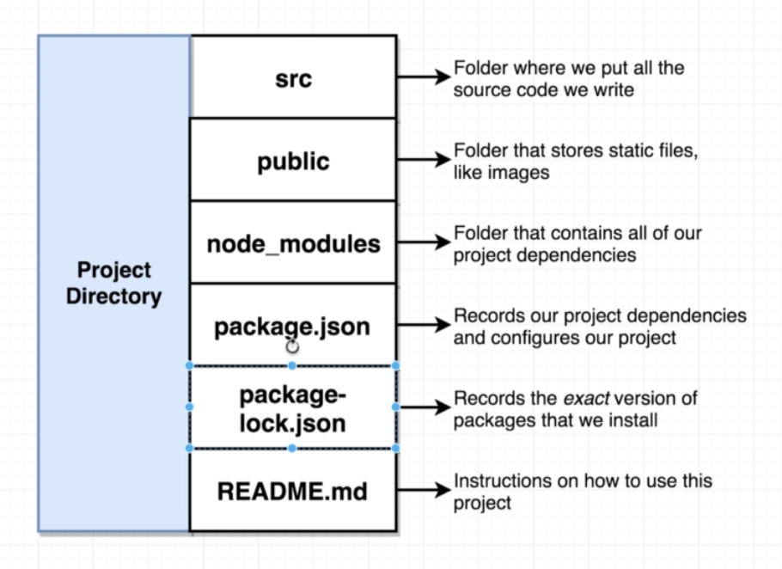

- use “npm start” from the project directory to start the project
- React Js follows module system, that is , every file created a react app is a small universe in itself and contents can’t be shared to outside world implicitly

3. How a React file looks like:
- React file commonly has these 3 steps:

a) Import react and react-dom
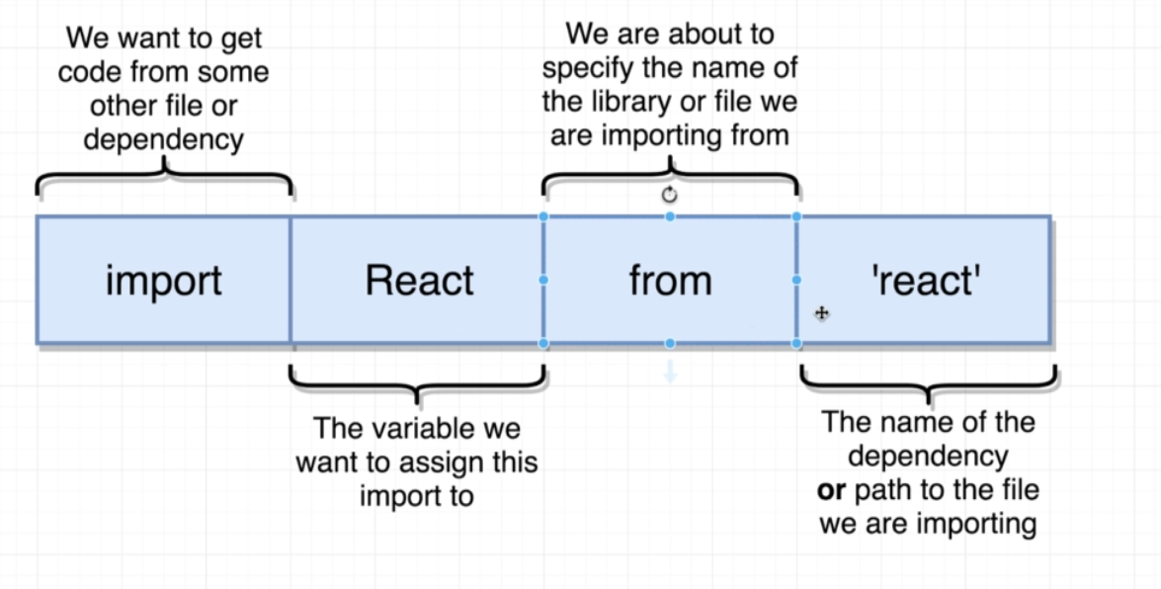
- We can import dependencies that are present in the ‘node-modules’ direcotry.
- Above, JS searches for the dependency ‘react’ from the ‘node-modules’ directory.
- The variable name above could be anything. We just use the same name as dependency by convention.

b) Create a react component:
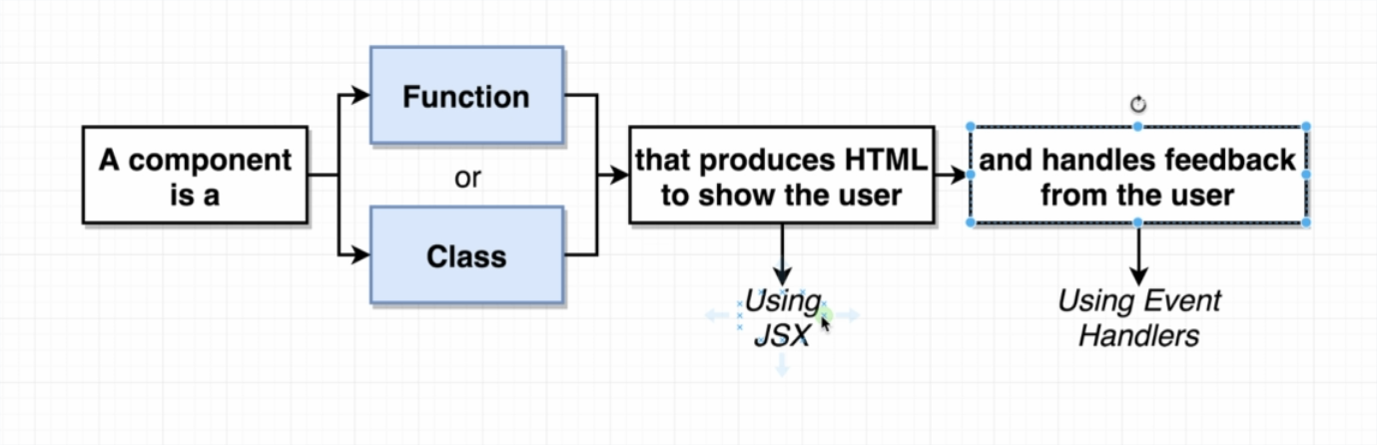
-

c) Show the react component on the screen using React DOM:

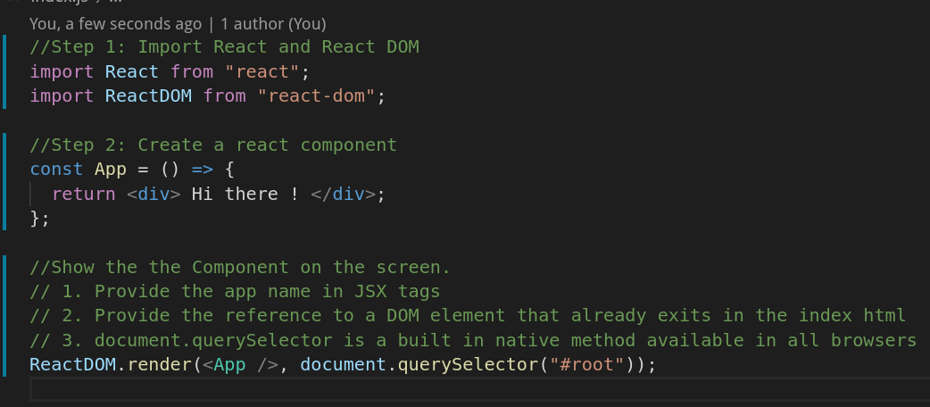

4. JSX:
- JSX is javascript extension.
- Its like HTML but not actually HTML.
- It represents the HTML component that we want to show on the screen.
- Babel takes JSX and converts it into js functions as the browser does not understand JSX
- We can directly write the js functions (for the corresponding jsx) but it becomes very large and difficult to understand for bigger components

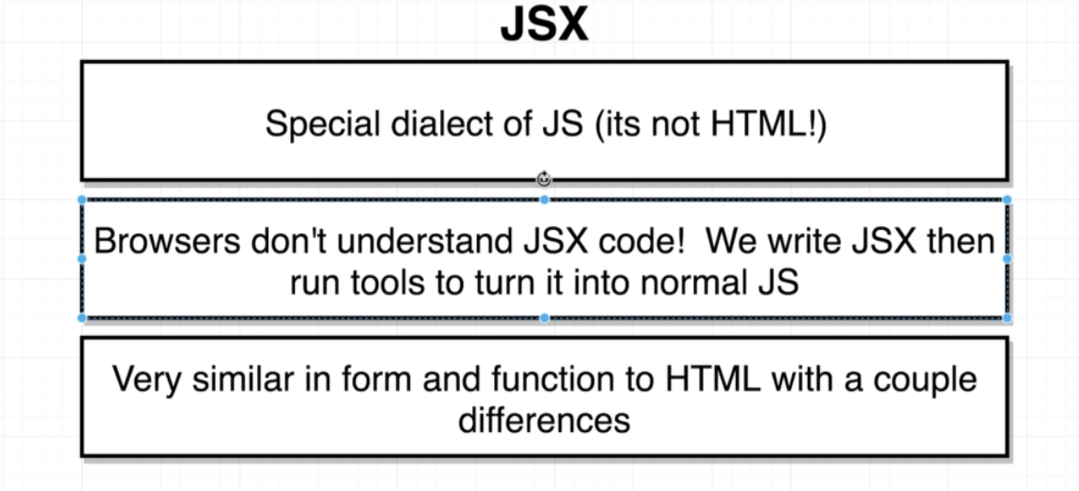

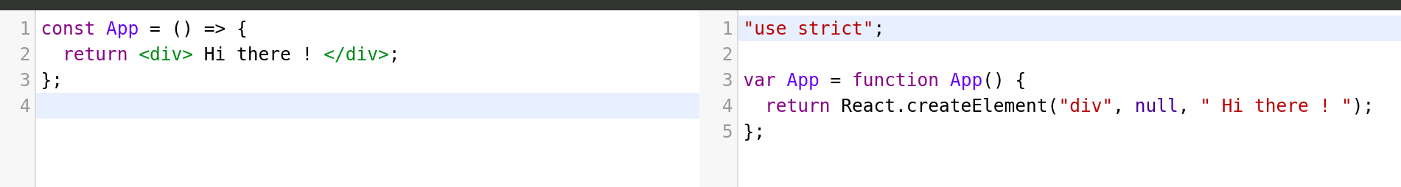

- HTML and JSX are not same.
- We can’t replace JSX with HTML in react.

JSX vs HTML:
We can’t directly use html syntax as JSX in react apps because of the following difference:

a) Adding Styling in JSX is different from HTML:
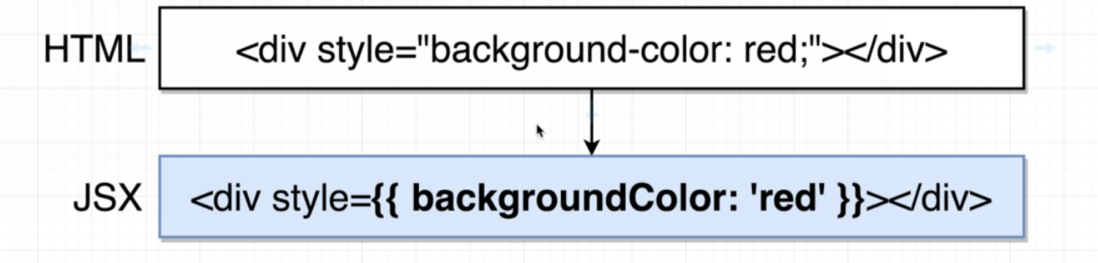

- First curly brace indicates that we want to reference a javascript variable inside the JSX
- Above, with JSX we are providing a Javascript object with the second curly braces
- Compound property name changes with ‘-’ replaced completed and next character capitalized.
- Values of the property should be in quotes

b): Adding Class to JSX:
- We are not supposed to be used ‘class’ inside a JSX element.
- We have to use ‘className’ instead.
- Because ‘class’ will have collision with ‘class’ based components.

c) JSX can reference JS variables:
- JS variables can used inside the JSX using single curly braces:
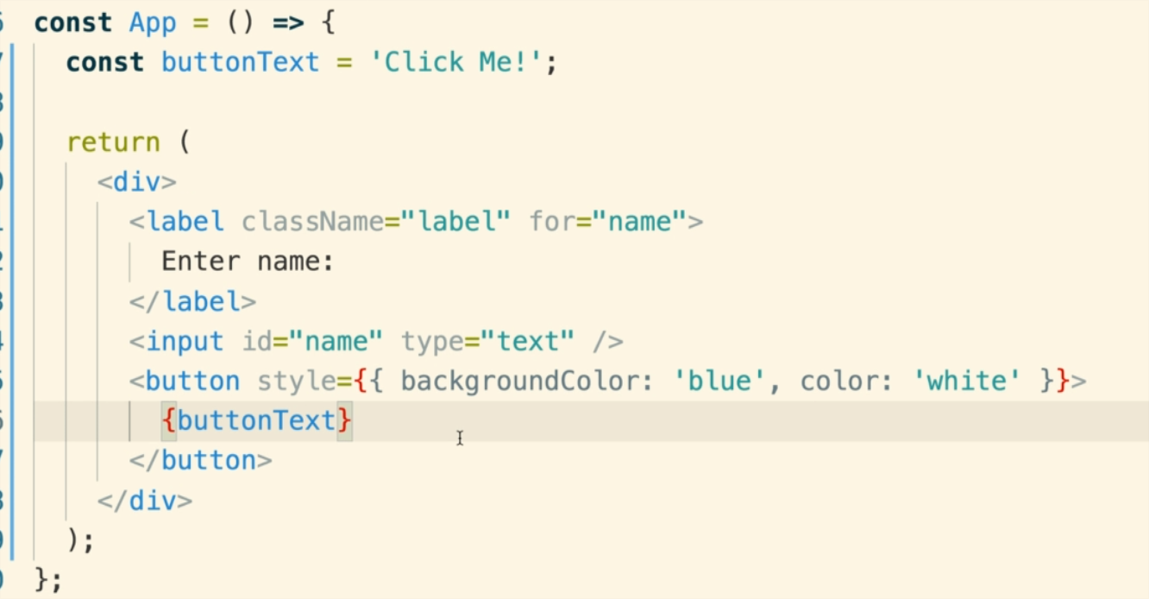
- Single braces in JSX means that we want to use javascript variable. ( it does not represent a js object)
- Second curly brace means that we want to use a javascript object

- IMPORTANT: We can’t show js object directly with curly braces in JSX to print them as text:
Following won’t work:
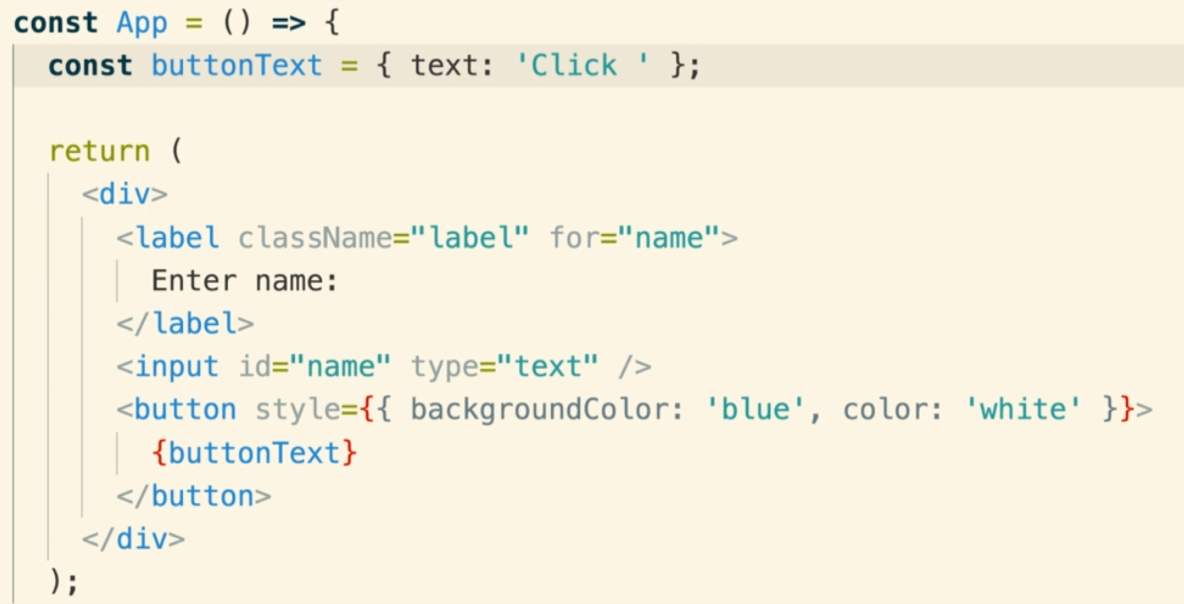

Reuse ability of Components:
- We should create reusable components by identifies the components that are used a lot and create them in a new file.
- The new component file should have naming convention as – CommentDetail.js

Component Nesting:
- By default, contents of on JS file is exclusive to that file only. Its not available to other files.
- By exporting the component in a js file, it becomes available for other files.
- The other files need to import the exported component in order to use it.

- Exporting and Importing Components:
a) One way is to use ‘export default <component name>’ at the bottom of the file.
b) While Importing, we need to give relative path to the file. (No JS extension after the file name is required in the import statement. Webpack handles that for us)

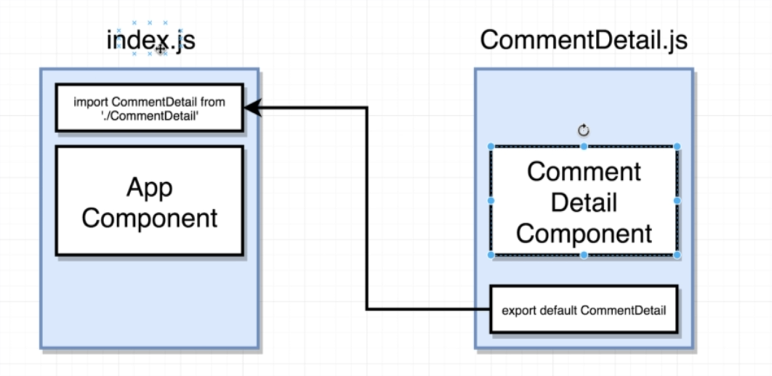

For Nesting one component into another, we can use the component in JSX tag inside another component

React Props System:
- A usual react app has one parent component and many child components.
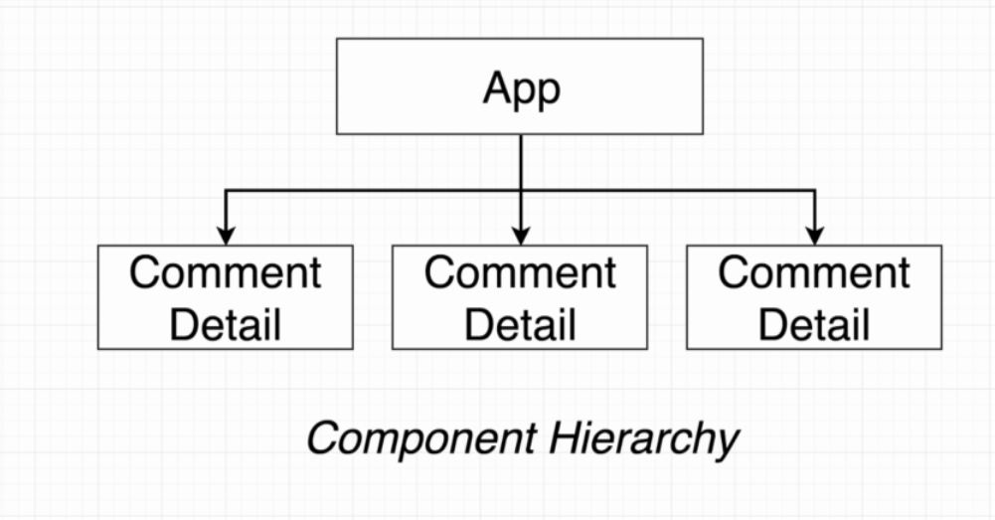

- The props system is React is used for passing data from Parent Component to the Child components.
- This helps in customizing or configuring the child to help it show some contents or to help the user interaction.
- We can share any amount of information in the prop system

Passing Data in Props System:
- Its a two step process:
a) Send data from Parent Component to child component.
b) Consume the data in the child component.
- To pass data from parent to child, we add properties (props) in the nested child component with appropriate values.
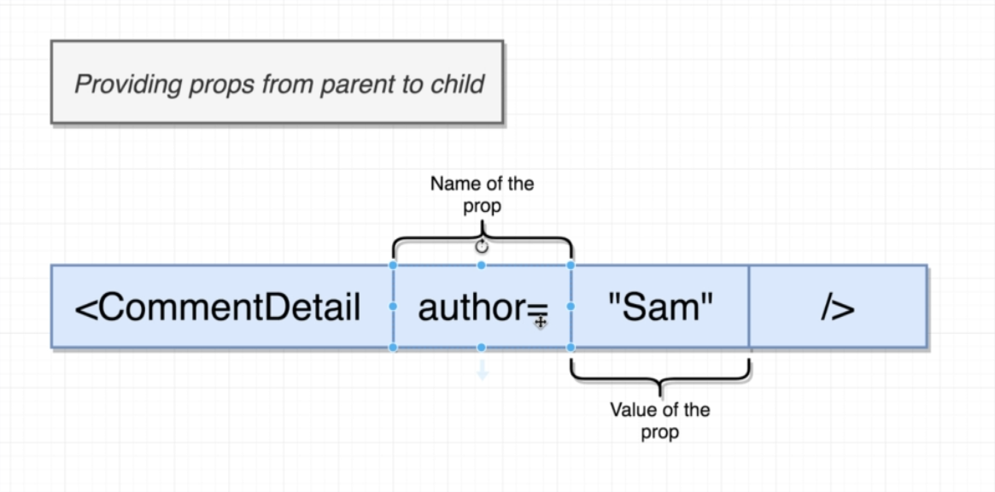

- Data sent to child can be consumed using the ‘props’ argument which is default first argument in any function based component.
(In case of class based component, we can just use ‘this.props’ to refer to the props send by parent component)

- Another way to send data is to wrap up the entire child component inside the parent component. This way, the data can be accessed using ‘props.children’
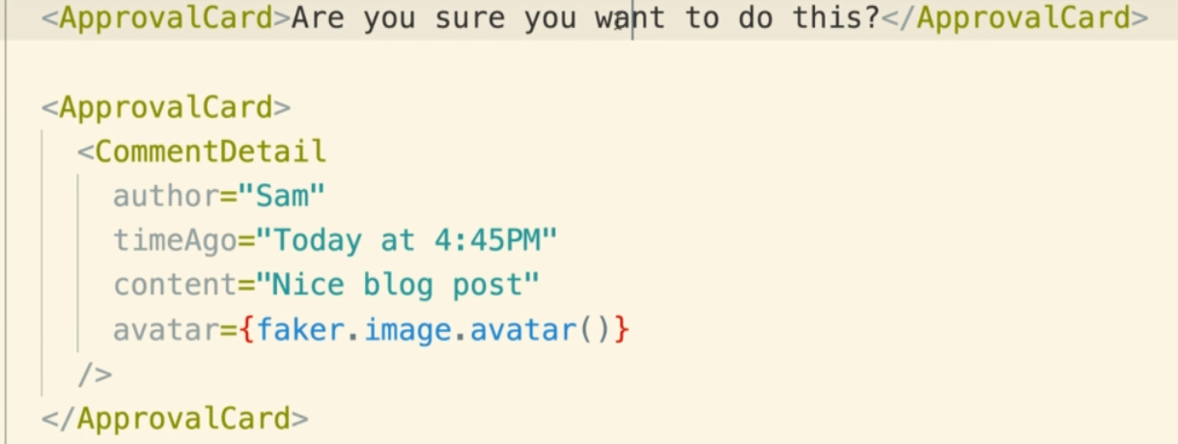
- Notice above that we can send both react component or plain text within a parent component. Both will be used as ‘props.children’ in the child component.

Note:

Functional Components Vs Class Based Components.

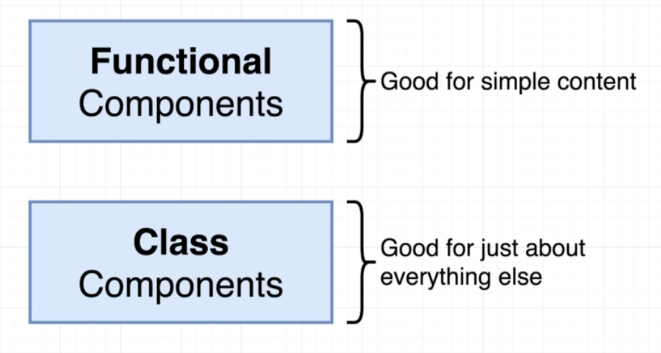

- If we are just creating a component which creates some JSX and displays it on the screen, then we can use Functional components.
- If we are having some sort of complexity in the components like we have to create network request, etc, then we use class based.

- Benefits of class based components:
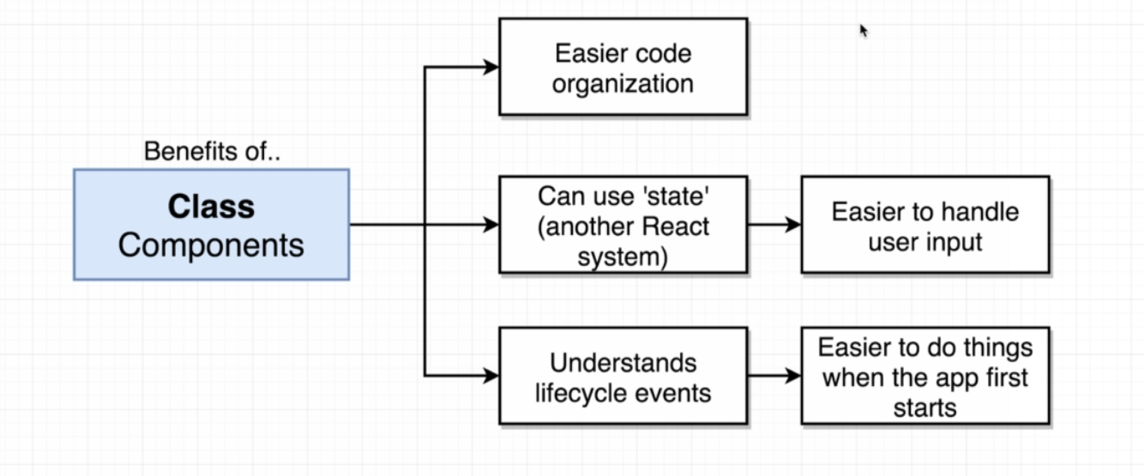
a) Class based components can use ‘state’ system in react.
b) We can make use of lifecycle events with class based components.

Creating a Class based components:
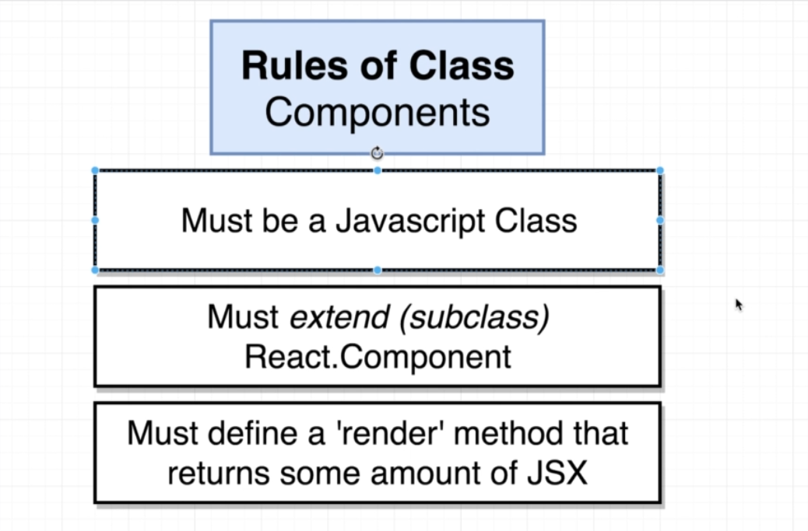

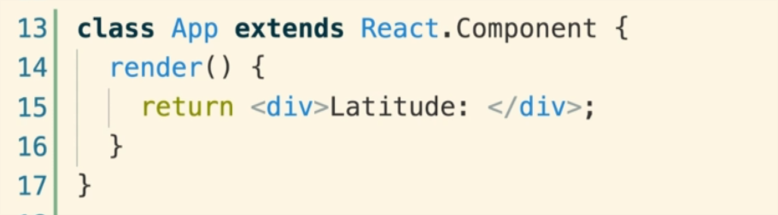
- The render method is required else we will get an error.

Using React JS state system:

Some Notes:
- States are only usable with class based components. ( We can use it functional components using hooks system).
- Don’t confuse props with state
- What is state: State is a js object that contains some amount of data relevant to the component.
- Updating ‘state’ on a component causes the component to re-render immediately.
- State has to be initialized when a component is created.
- IMPORTANT: State can only be updated using the function ‘setState’

Constructor function:
- Its the first function that is called when the class is created.
- we can set our state inside the constructor function.
- Constructor function calls state function.
- First statement inside the constructor should be ‘super(props)’.
- Super is the reference to the parent classes constructor.
- We use super here to match the ‘React.Component’ class’s constructor class.
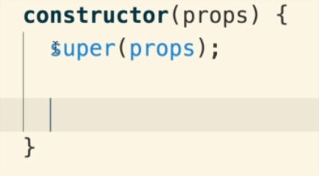

- We can create our state object inside constructor using ‘this.state = { }’
- We default the initialization to null if we don’t know the value.
- Once initialized, the state and its properties can be referenced anywhere inside the component.

IMPORTANT:
- We can only change the state using ‘this.setState()’ method.
- We should never change state using “this.State.SomeProp= someValue”
- The only time we use ‘this.State’ is when we initialize the state for the first time.
- Changing the state of the component re-renders the component with the updated value
- With SetState we only add or update properties on our state but never remove or delete..
- Updating single property on the state does not affect the other properties
- State from one Component can be passed as a prop to the child component.

Note:
- Ensure that you remove the semicolon when converting single line jsx into multi line.

Component Lifecycle Method:
- We have component lifecycle methods that can be used with class based components (not with functional).
- These are methods that are called automatically by react are certain time during the component lifecycle.

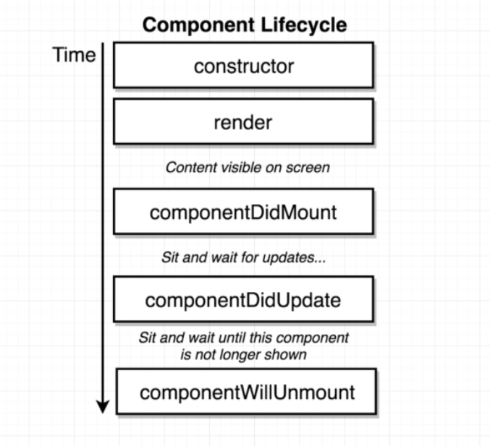

Methods:

a) constructor:
- called when new instance of the class based component is created.
- Good place for any one time setup
- (officially, its not a good practice to do some data loading (api calls etc) inside a constructor. Data loading code should be placed inside ‘componentDidMount)

b) render:
- Its not an optional method and should be created by user.
- Avoid doing anything besides creating and returning JSX.

c) ComponentDidMount:
- Called once when the component first gets rendered on the screen
- good for one time initialization

d) ComponentDidUpdate:
- Called every single time when the components is updated for any reason. (usually when the state is changed).
- Render method is usually called right before componentDidUpdate is called.
- Example use: make a network request when use clicks a button

e) ComponentWillUnmount:
- When the component is no longer shown, like after some cleanup of the component.

Some rarely used lifecyle methods:
f) shouldComponentUpdate.
g) getDerivedStateFromProps
h) getSnapshotBeforeUpdate

- Two ways of initializing the state:
1. Initializing the state inside the constructor
2. Just writing in the class
- state = {lat: null, <someprop>: <someValue>}
- bable converts the above line to something to what we have in #1 above.

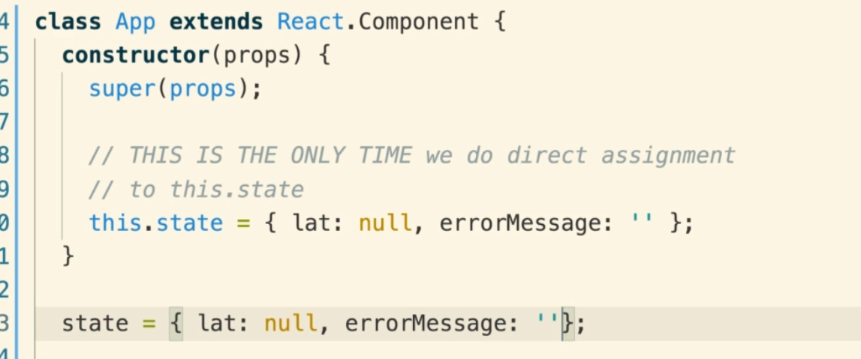

Event Handling:
- For event handling we can create functions and add them as call back functions to the event handler properties (like onClick, onSubmit) in jsx.
- Remember that is a call back function and should not have parenthesis after it.
- putting Parenthesis will call the method every time the component is rendered, which we don’t want. Only want the function to call when some event has happened:
For example:

- Observe that there are no parenthesis after {this.onInputChange} call back in the diagram below
- Default argument passed to the call back event handler function is ‘event’
- ‘event.target.value’ property will have necessary details.

Some other useful event handler properties:
- onChange: user changes the text in an input
- onClick: when something was clicked.
- onSubmit: When a form is submitted.

- Naming convention for event handler helper methods:
<on><Element Being affected><Event we are watching for>
for example : onInputChange()

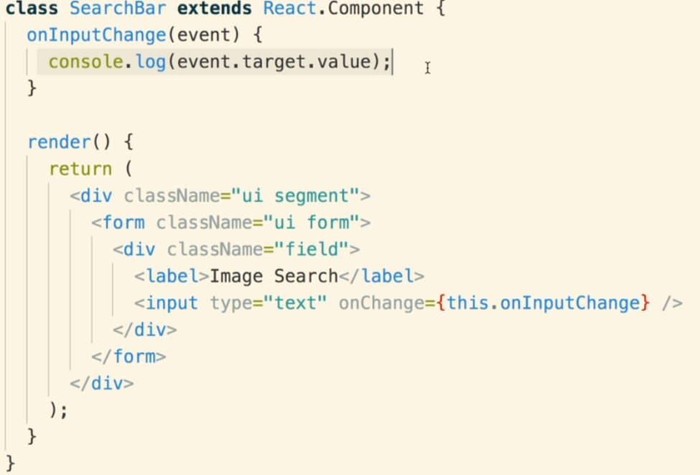

Alternate way of writing event handler:
- We can use an abbreviated syntax where we don’t have to define a separate call back method and use a arrow function in the jsx itself.
- This is useful to execute a single line of code when some event occurs.

Controlled vs Uncontrolled Components:
- We always prefer to work with Controlled events.
- In uncontrolled events, we don’t have much idea about the value the flowing through the react component.
- We have to depend on the DOM to know the value, which is not a good thing.
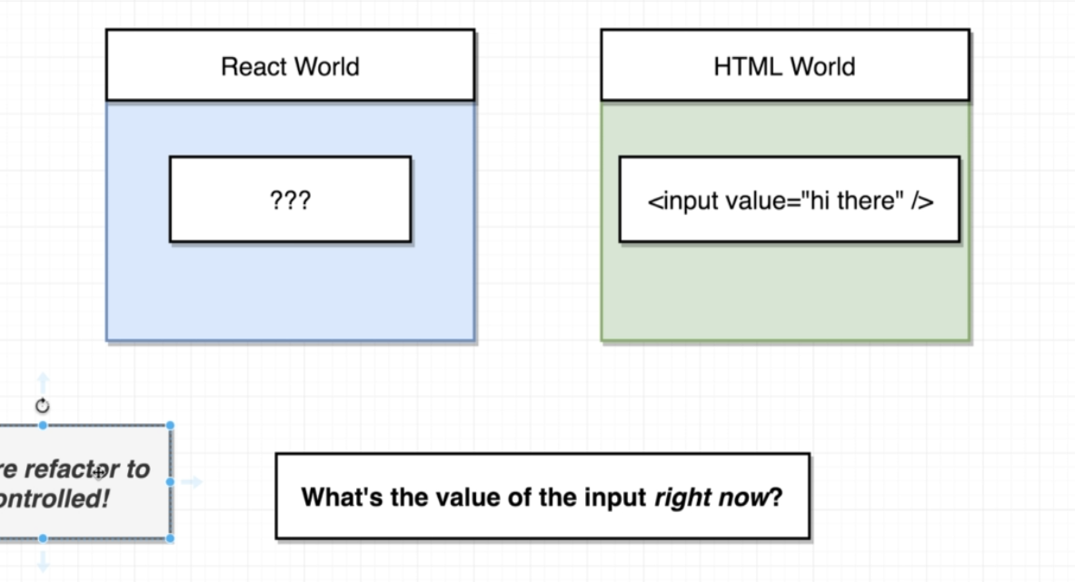
- Controlled events on the other hand gives has more power to always know the value that is in the jsx.
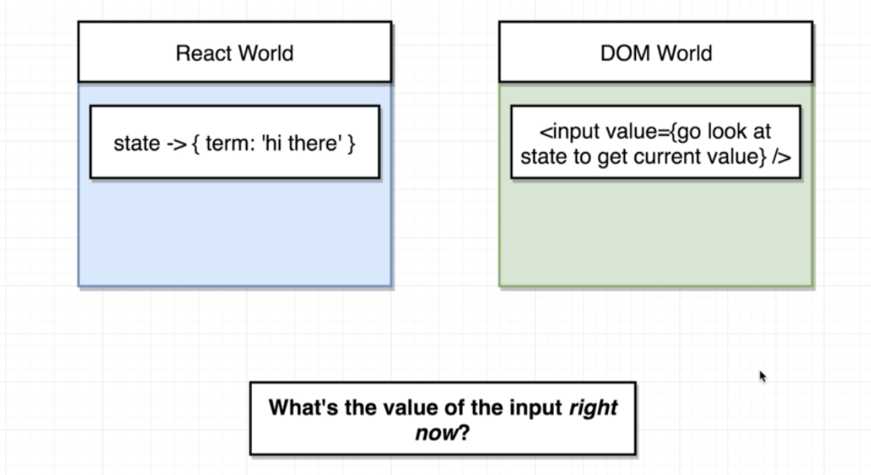
- We don’t have to refer the DOM to know the value.
- We can directly use the react component to get the value.
- We use state to create the controlled component.

The key difference is that we store the value/useful info inside the react component using the state object instead of storing information in the DOM

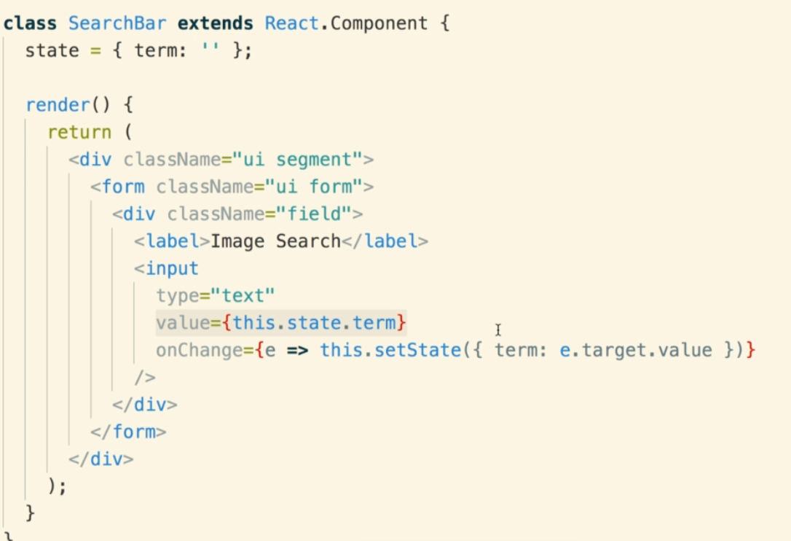
- One downside of this approach is we are doing extra things as <input> already knows about the user information. We are adding the same info again back into the component. But it keeps the info inside the react component only and we don’t have to ask the DOM for the value.

Two advantages of using this controlled components approach:
1. We can use some default value.
2. We can do some things based on every single piece of information that use enters.

This is Javascript:

- ‘this’ works differently when used inside a Class vs Function.
- Inside a class, ‘this’ refer to the class itself. Using ‘this’ we can refer to the different properties of the class.
- Inside a function if we use this, we look at how the function is invoked, or more precisely, what’s before the ‘.’ operator when that function is invoked.
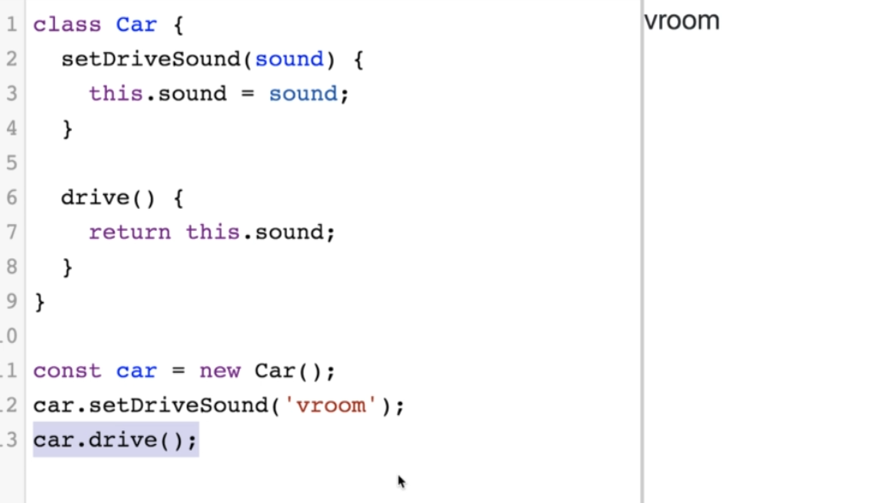
- Here ‘this’ is used inside the ‘drive()’ method.
- So we check how is ‘drive()’ called.
- Its called using ‘car.Drive()’ and ‘car’ is an instance of ‘Car’ class here.
- So ‘this.sound’ inside the ‘drivee() mehtod is ‘car.sound’.

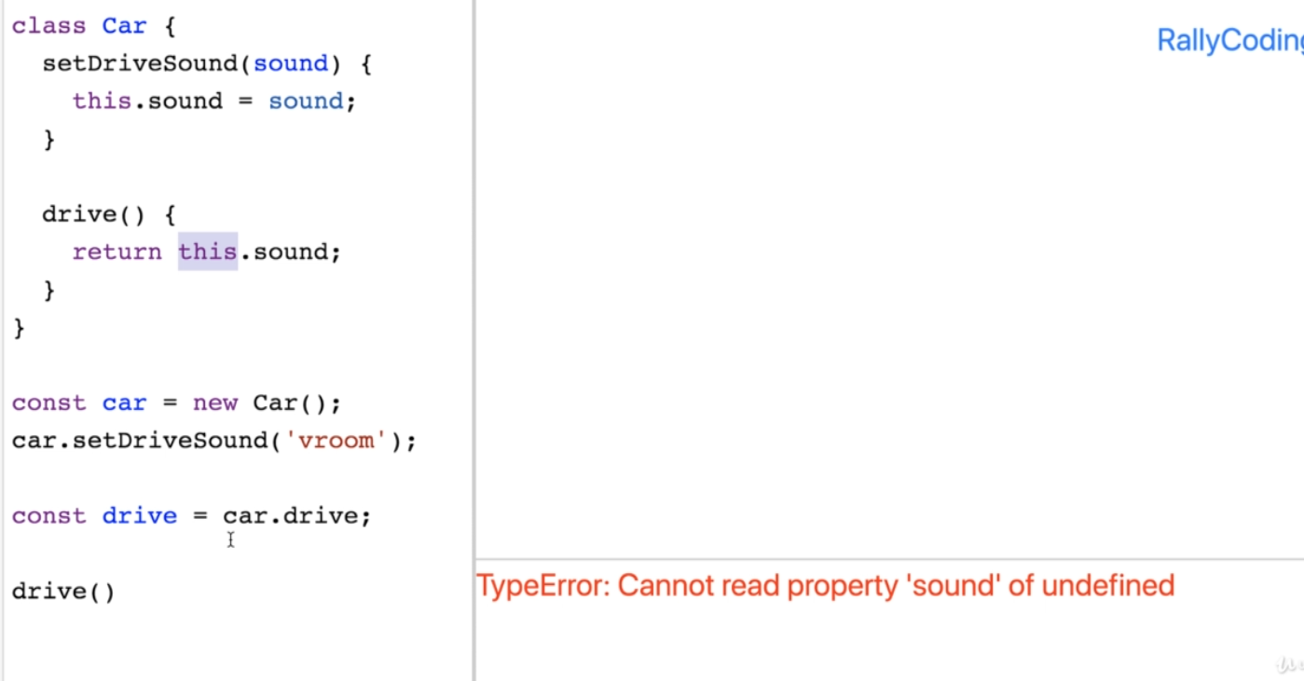
- In this case, there is nothing before the ‘drive()’ invocation.
- So ‘this.sound’ inside the ‘drive()’ method is more like ‘undefined.Sound’.
- Hence the error.
- This is one of the most common type of errors in react js

The case of Broken ‘this’ inside React js functions
- A very common error is React is around the use of ‘this’ inside a function.
- where ‘this’ someone becomes ‘undefined’ inside the function due to some backend code changes.
- We can fix this by”
a) using ‘bind’.
b) using only ‘arrow’ function convention when creating a new function
c) use arrow function right in the jsx and call the actual event handler function:

Communicating from Child back to Parent Component:
- Props are used to send data from Parent to Child components.
- Props can’t be used other way around.
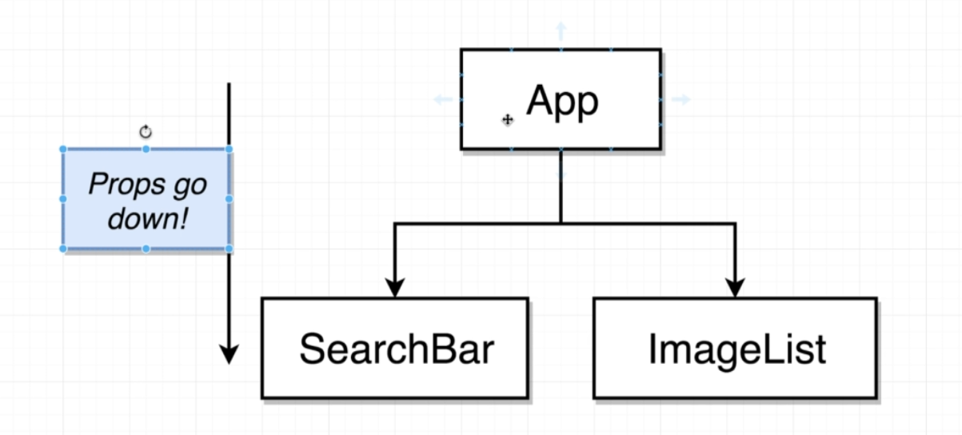

- To send data from Child to Parent, we can:
a) create a call back method in the parent component.
b) send the call back method to the child component using props. Child component will hold onto that call back method.
c) Child component will call that call back method (inside the parent component) when some appropriate event happens. For example, user has entered a search term. Call back method will be called with that search term.

Redux:
- Its a library to maintain state
- Helps reduce complexity of larger projects.
- Main purpose of React is the create components and handle user events. It should not handle the state . And this can be handled by Redux.
- Its difficult to understand to start with. But becomes easier and starts making more sense by time.

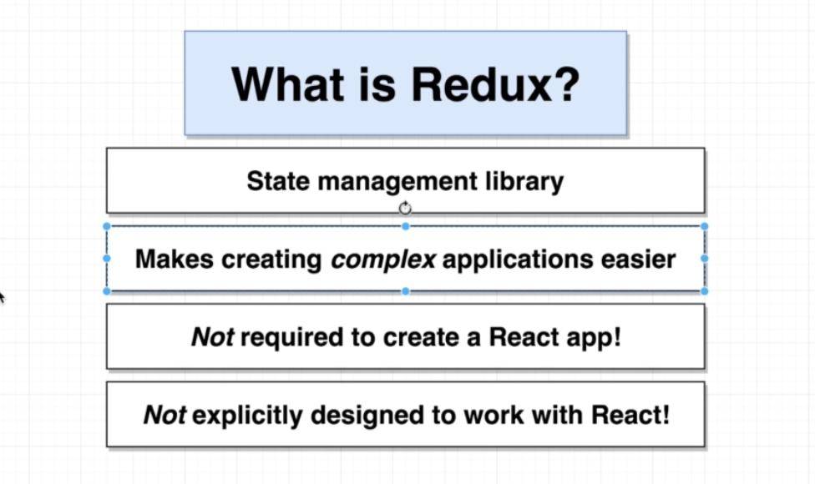

- Redux cycle:
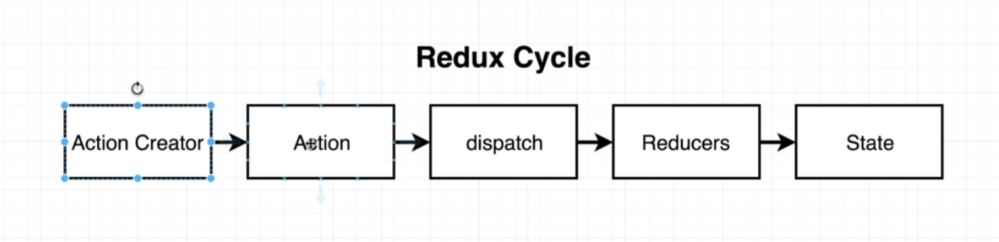

- Redux cycle and Insurance analogy:
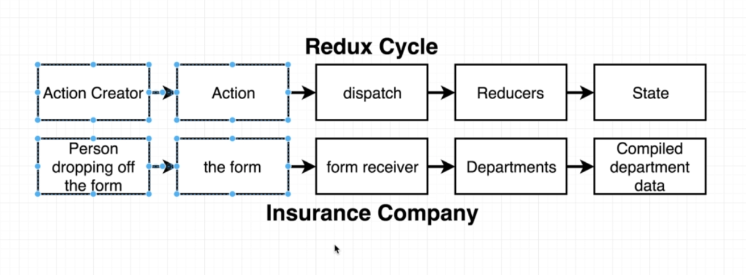

a) Action Creator:
- a function that returns a plain javascript object.
- This object is called an ‘action’

b) Action:
- is a javacript object.
- It has two kinds of values:
- Type: Purpose of the action. (Mandatory)
- Payload: Provides some context on what this action is doing. (Optional)

c) Dispatch:
- It takes the action and sends it across to all the reducers.
- This is a built in feature in Redux
- Each dispatch will again start the entire redux cycle

d) Reducers:
- are functions.
- Take some existing data and ‘action’.
- Check the type of action and based on the ‘type’, reducers decide how to modify the existing data.
- Reducers should always return something
- Make sure we are not modifying an existing array/record inside the reducers and always returning a new collection. That is, never use ‘push’ function inside ‘reducer’

CreateStore and CombineReducers:
- Once we create our reducers and actions creators we need to wire them all together in single object called Store.
- CombineReducers wire up alll the different reducer functions together
- The keys used in the combineReducers finally reflect in the ‘state’ property name
- We can use any key we want but by convention it should same as the reducer name
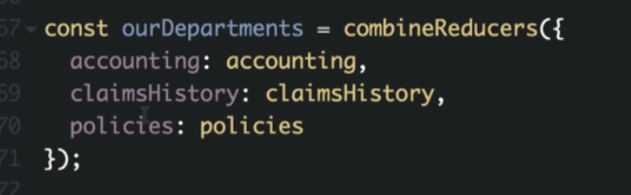

Example
//People dropping of form (Action-Creator)
const createPolicy = (name, amount) => {
return {
type: "CREATE_POLICY", //Upper case by covention
payload: {
name: name,
amount: amount,
}

};
}

const deletePolicy =(name) => {
return {
type: "DELETE_POLICY",
payload:{
name: name,
}
};
}

const createClaim = (name, amountofMoneyToCollect) => {
return {
type: "CREATE_CLAIM",
payload: {
name: name,
amountofMoneyToCollect: amountofMoneyToCollect
}
};
}

//Reducers (are like departments)

const claimsHistory = (oldListofClaims = [], action) => {
//The firs time claimHistory is called, the oldListofClaims will be undefined.
// So we write oldListofClaims=[] that converts undefined to an empty array.
if (action.type == "CREATE_CLAIM"){
//we care about this action Form
//Creating a brand new array and adding new records to it.

return [...oldListofClaims, action.payload]

//using push oldListofClaims.push(action.Payload) does not creat a new array.
}

// We don't create about the action (form !)

return oldListofClaims;

};

const accounting = (bagOfMoney = 100 , action) => {
// firs time the account reducer is called, bagOfMoney will be undefined. So it intiailzed to 100 if undefined.
if (action.type === "CREATE_CLAIM"){
return bagOfMoney - action.payload.amountofMoneyToCollect;
} else if (action.type == "CREATE_POLICY"){
return bagOfMoney + action.payload.amount;
}
return bagOfMoney
};

const policies =(listofPolicies=[], action) => {
if (action.type === "CREATE_POLICY"){
return [...listofPolicies, action.payload.name]
} else if (action.type === "DELETE_POLICY"){
return listofPolicies.filter(name => name !== action.payload.name)
}
return listofPolicies
};

const {createStore, combineReducers} = Redux;

//Combine all the reducers.
const ourDepartments = combineReducers({
accounting : accounting,
claimsHistory: claimsHistory,
policies: policies

});

const store = createStore(ourDepartments)
//Store object now represents our entire redux application.
// store has reference to all of our different reducers and state produced by those reducers.

store.dispatch(createPolicy("Alex", 20))
store.dispatch(createPolicy("Rude", 20))
store.dispatch(createPolicy("Anju", 80))
store.dispatch(createClaim("Alex", 20))
console.log(store.getState())// get entire assembled repository of data

Redux State:

- Each dispatch call performs this following redux cycle.
- State can only be modified using the dispatch function by passing it appropriate actions.
- We can’t modify the state directly
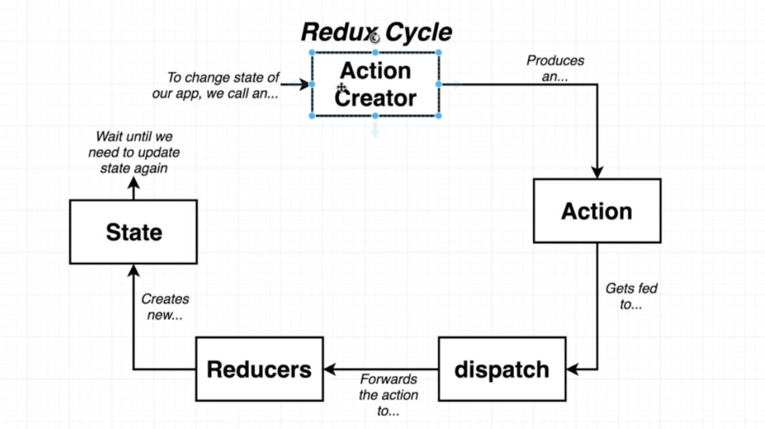

REACT WITH REDUX:

- We use ‘React’, ‘Redux’ and ‘React-Redux’ libraries to work with redux and react.
- We can download the dependencies by:
npm install –save redux react-redux

React-Redux:

a) Provider Component:
- Instance of Provider Component can be created using ‘react-redux’.
- Redux Store (collections of reducers and state) is passed on as a prop to the provider component.
- Provider is rendered the top level of application hierarchy.
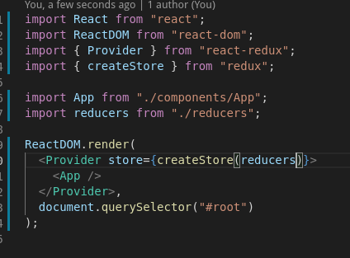

- Thus providing the essential information to all the different components inside our app.
- After wiring up the Provider, we need to find all the different components of the application that needs access to the data available in the redux store.

b) Connect Component:
- It communicates with the ‘Provider’ component that’s at the top of the hierarchy using the ‘context’ system.
- Context system allows a parent component to directly connect with a child component even if there are any other child components in between.
- Connect component will connect with the Provider to fetch data and pass that data into the App components that need it

- We can import connect and use it at the end of the file.
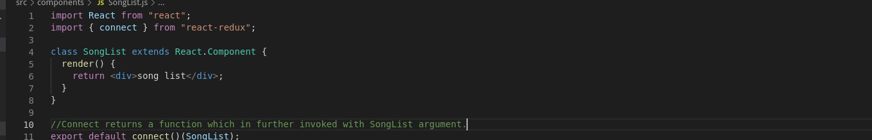
How the strange syntax of connect works
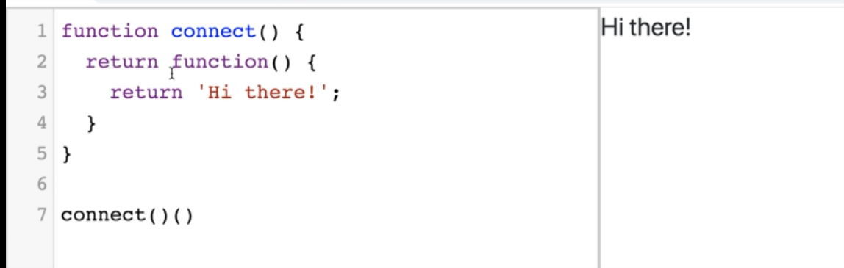

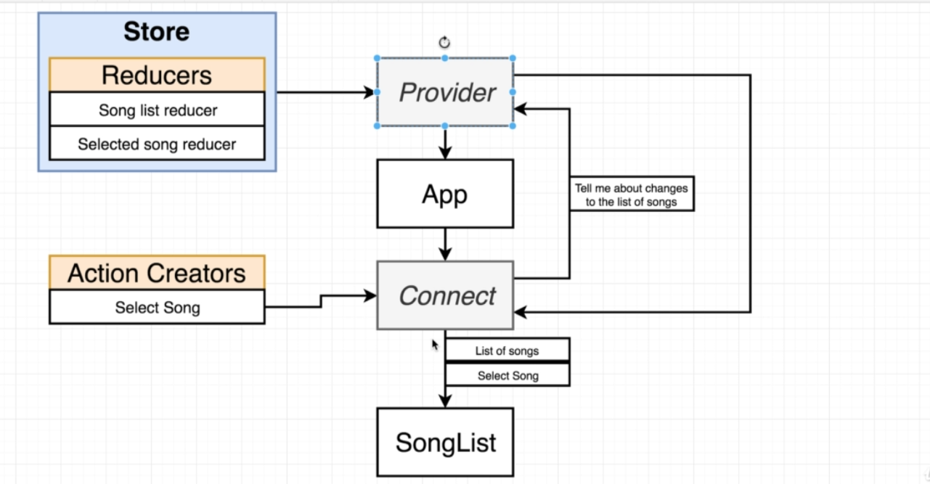

- Provider and Connect components are provided by the react-redux library
- Store contains all of our reducers and all of the state of our application.
- Store is added to the Provider as a prop.
- Provider is the first thing that runs in our application.
- Connect component can communicate with the Provider component which is at the very top of the hierrarchy

- The index.js file in a directory can help as shortcut while importing.
- If we only specify the directory name while importing, web pack will import the index.js file in that directory.

- React Redux Project Structure:
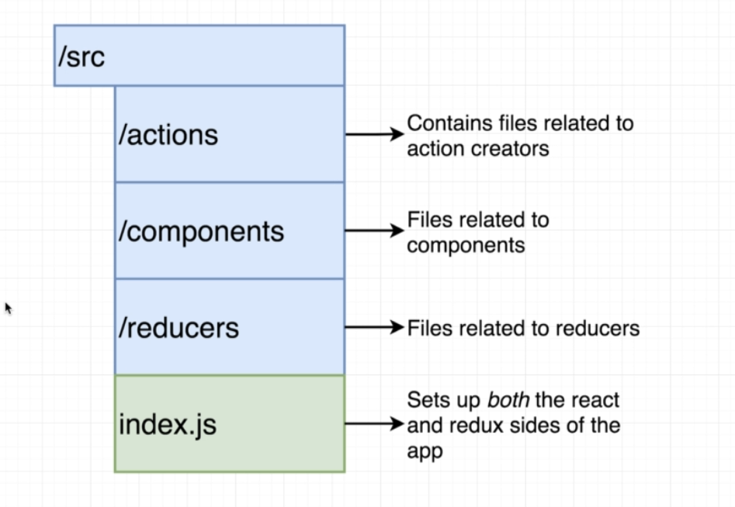

Named vs default exports:

- Default export allows us to export only function function from a file.
Syntax: export default <function_name>
No need to curly braces while importing default exports.

- Named export allows us to export many different function from a single file.
Syntax:
- We can use ‘export’ keyword before the name of the function to use named export.
- The way of importing named export is also different. We have to {} in the import statement when using named export.


